DÜNDAR EVİ(HAGİOS LOANNES KİLİSESİ)
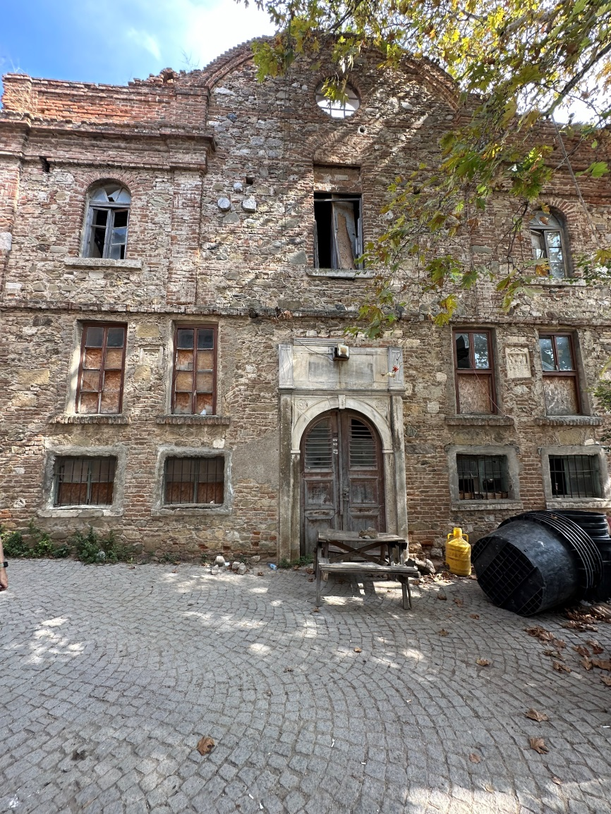
Taş Mektep’in kuzeyinde Marangozhane Sokak üzerinde bulunan kilisenin ilk yapım tarihi bilinmemekle beraber, Osmanlı arşivlerindeki 1894 tarihli belgede 19. Yüzyıl sonunda yeniden inşa edildiğine dair bilgi bulunmaktadır. Mübadele sonrası Rumların köyü terk etmesiyle işlevsiz kalan yapı konut olarak kullanıldığından dolayı bölgede “Dündar Evi” olarak bilinmektedir.
Batı-doğu doğrultusunda üç nefli bazilikal planda inşa edilen kilisenin narteks ve galerisine konut, üst örtüsü yok olan ana ibadet mekânı ve apsislere bahçe işlevi verilmiştir. Yapının kuzey duvarındaki üç pencereden birinin altına duvarın yıkılmasıyla kapı açılmış, diğer ikisinin de kemer başlangıçlarına kadar tuğla ile duvar örülmüştür. Güney duvarında ise galeri merdivenindeki giriş ve pencere ile nartekse açılan kapı duvar örülerek kapatılmıştır. Kilisenin duvarları apsis duvarları hariç, moloz, taş, tuğla ve devşirme malzeme kullanılarak almaşık teknikle örülmüştür.
1923 sonrası mübadele ile kilisenin mülkiyetinden çıkan yapının mülkiyeti şahıslara geçmiş bulunmaktadır.

DÜNDAR HOUSE (ST. JOHN CHURCH)
Although the first construction date of the church, located on Marangozhane Street, north of Stone School, is unknown, there is information in the document dated 1894 in the Ottoman archives that it was rebuilt at the end of the 19th century. The building, which became dysfunctional after the Greeks left the neighbourhood after the population exchange, is known as "Dündar House" in the region because it was used as a residence.
The narthex and gallery of the church, which were built in a three-naved basilical plan in the west-east direction, were used as residences; the main worship space and the apses which have no upper cover, as garden. A door was opened under one of the three windows on the north wall of the building with demolition of the wall, and the walls of the other two were built with bricks up to the beginnings of the arches. On the south wall, the entrance at gallery staircase and the window as well as the door opening to the narthex were closed by building a wall. The walls of the church, except the apse walls, were built with an alternative technique using rubbles, stones, bricks and spolia materials.
After 1923, with the population exchange, the property of the building, which was no longer owned by the church, was alienated to individuals.

